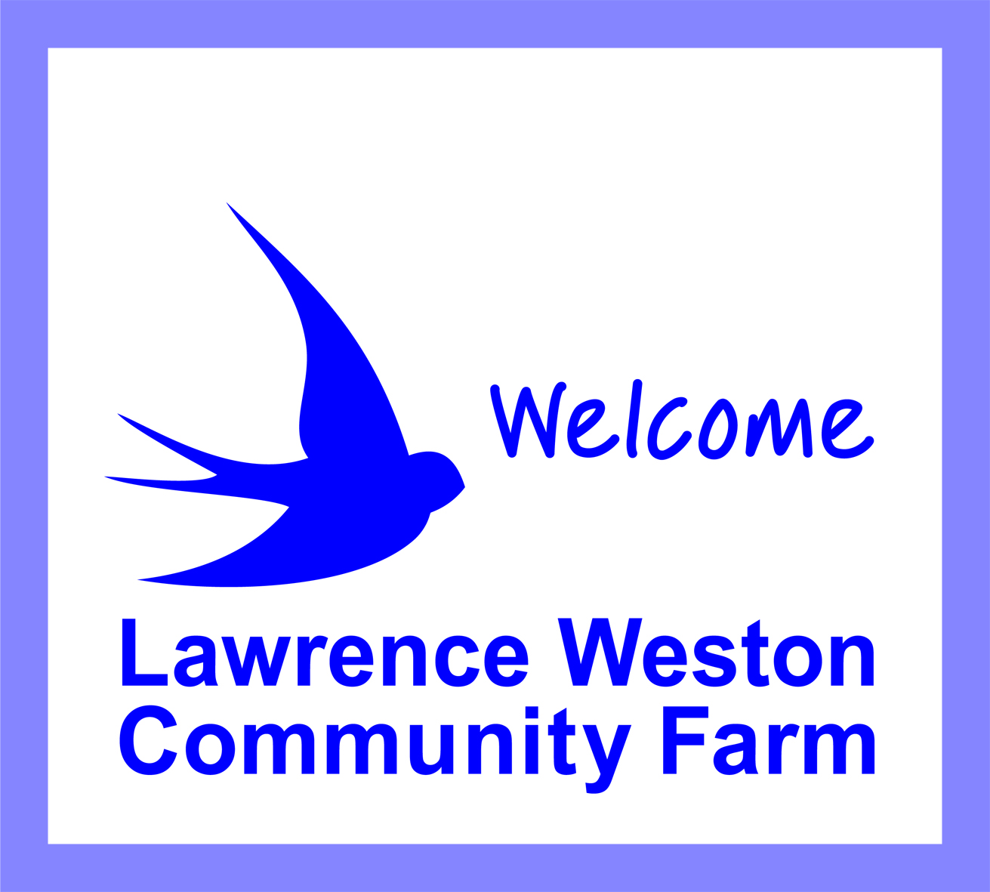

Saltmarsh Drive Lawrence Weston Bristol BS11 0NJ

0117 938 1128
www.lwfarm.org.uk
Lawrence Weston Community Farm

Guidance on Room Hire with Covid-19

The following guidance will remain in effect while the potential transmission of COVID-19 remains a public health threat. The responsibility for controlling any risks associated with the transmission of Coronavirus is shared between the farm and the hirer of the rooms.

Responsibilities of the farm

- All hirers of rooms will be advised of the additional guidelines in place to reduce potential transmission of disease.
- All rooms will be cleaned between room bookings in a manner that reduces potential transmission of disease.
- Basic cleaning materials will be provided in rooms to enable surfaces to be cleaned by hirers during room hire
- Hirers are asked to wash their hands on arrival and observe social distancing on the farm.

Responsibilities of the hirer

- No-one shall be allowed to use the facilities if they are displaying symptoms of Coronavirus. If a person with such symptoms enters the premises they must be sent home immediately and the farm informed of their presence on site including time and duration of stay and areas in which they were present.
- Group activities must be conducted in a manner that is compliant with current public health advice, including any social distancing measures extant at the time of hire. The maximum number of people able to use the Community Room with 2m social distancing is 8. If masks are worn 16 people can use the room.
The maximum number of people able to use the Training Room with 2m social distancing is 19, and 38 with masks. Take additional measures where possible, such as keeping the windows open.
- Groups will follow the guidance issued from time-to-time by farm staff with regard to measures put in place to minimise risk (e.g. limited access or one-way systems).

